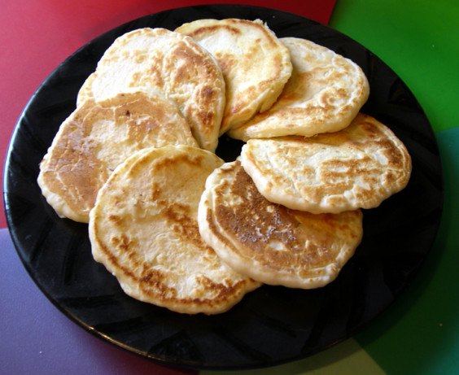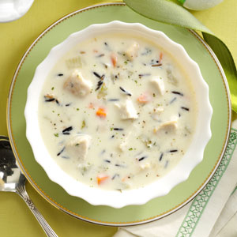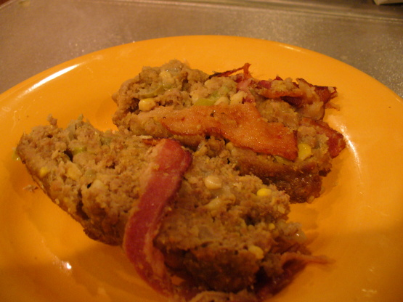

Ingredients:

3 quarts popped popcorn, 3 tablespoons melted butter/margarine, 1 ½ teaspoons poultry seasoning, ½ to ¾ teaspoon cayenne, salt

Prep:

In a large bowl mix popped popcorn with melted butter/margarine, poultry seasoning, cayenne and salt to add flavor.

http://www.myrecipes.com/recipe/potawatomi-popcorn

Ingredients:

2 cups flour, 1/8 salt, 2 teaspoon baking powder, ¼ cup dry milk, 1 cup warm water, ¼ cup shortening/lard

Prep:

In bowl, mix all but shortening/lard. Mix till smooth. In skillet, heat shortening/lard till melted. Using wooden spoon scoop large spoonful from bread batter and place in shortening. Cook for 30 seconds(or until bottom is slightly firm. Turn over and flatten with spatula. When light brown on edges, flip again till edges are browned. Server warm.

http://www.food.com/recipe/seneca-ghost-bread-95915

### Appetizer:

### Seneca Ghost Bread

## Snack:

## Patowatomi Popcorn

A taste of the Tribes

In

Recipes

Introduction

to

* Native American Food

Ingredients:

½ cup butter, 2 carrots (fine chopped, 2 celerey ribs ( fine chopped, 1 medium onion (chopped), ½ cup all purpose flour, 4 cups chicken/turkey broth, 2 cups cooked wild rice,2 cups cubed cooked turkey

2 cups half and half cream, 1tsp, dried parsley flakes, ½ tsp salt, ¼ teaspoon pepper

Prep:

In dutch oven, heat butter over medium high heat . Add carrots, celery and onion and stir till tender. Stir flour until bleade, cook until bubbly. Gradually whis in broth. Bring to boil, stir constantly, cook and stir for 1-2 minutes or until thickened. Stir in remaining ingredients: return to boil. Reduce heat: simmer for 20 minutes (stir occasionally) . 12 serving yield ( 3 quarts)

http://www.tasteofhome.com/recipes/turkey-wild-rice-soup

Poyha continued:

Set aside. You may add optional garlic salt/ paprika to the bowl as well. In cast iron skillet/dutch oven brown ground meat in oil or in raw bacon pieces ( do not overcook). Add drained meat to corn mixture. Wipe out skillet or dutch oven with paper towel. Season with grease or oil. Add cornmeal to meat and corn mix. Mix well. Add more cornmeal (a little at a time if the mixture is overly runny). Pack into skillet/Dutch oven, cover. Grill on medium heat for 45 mins – 1 hr. Cool at least 15 mins. Cut slices in the Dutch oven and lift slices out to serve dish

[http://www.food.com/recipe/poyha-old-native-american-recipe-meat-cormeal-174079](http://www.google.com/url?q=http%3A%2F%2Fwww.food.com%2Frecipe%2Fpoyha-old-native-american-recipe-meat-cormeal-174079&sa=D&sntz=1&usg=AFQjCNEo2n-8r60WqU6rf_ciMXxeRuyB2Q" \t "_blank)

Ingredients:

2lbs ground beef/ venison/elk/ turkey/chicken, 3 tbsp oil, 3 slices bacon (chopped, if you are not using the bacon as pan dripping, add ½ tsp salt \*optional, or three slices salt substitute \*optional), 2 (14 ounce) cans whole kernel corn or 2 cups thawed frozen corn, 2 cups green seedless grapes (chopped fine), 1 large diced yellow onion, 3 eggs,1 ¼ cups coarse yello corn meal, ½ tsp pepper, cooking spry, paprika \*optional, ½ tsp garlic salt \*optional.

Prep:

In blender, chop corn till small pieces. Set aside. In large bow, add chopped corn, chopped grapes, onion, eggs, pepper. Beat until eggs are mixed.

Entrée: Poyha